**Try - catch**

1, Try catch is to handle the unexpected issues at runtime - Eg below

* Cannot read or write the file
* unable to connect to database due to network issues
* due to wrong inputs from user

2, To know about the exception s hover over constructor to get all exceptions

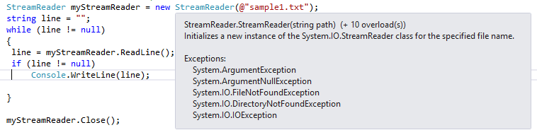

3, **Best Practice : -** Catch specific exceptions first and generic to the last

4, only **one catch block** is executed among multiple.

